**Title in English (Times New Roman; size-14; Interline simple)**

***Title in Arabic (t.arabic 16)***

|  |  |  |
| --- | --- | --- |
| **name of the first author[1]**  *Full affiliation,*  *Email addres* |  | **name of the second author** *Full affiliation*  *Email address* |

*Received: 00/00/0000 Accepted: 00/00/0000 Published: 00/00/0000*

|  |
| --- |
| **Abstract: Max 150 words**  *The abstract includes the objectives of the article and its problematic, the contents of the article ,and the substantive results. The abstract includes the objectives of the article and its problematic, the contents of the article ,and the substantive results. The abstract includes the objectives of the article and its problematic, the contents of the article ,and the substantive results. The abstract includes the objectives of the article and its problematic, the contents of the article ,and the substantive results. The abstract includes the objectives of the article and its problematic, the contents of the article ,and the substantive results. The abstract includes the objectives of the article and its problematic, the contents of the article ,and the substantive results.*  ***Key words: word1, word2, word3; word4, word5***  **Abstract In Arabic (***t.arabic 14***)** |

**1. INTRODUCTION**

**2. First Subtitle**

The first subtitle opens with an introduction that presents the specific problem under study and describes the research strategy. The first subtitle opens with an introduction that presents the specific problem under study and describes the research strategy. The first subtitle opens with an introduction that presents the specific problem under study and describes the research strategy.

**3. Second Subtitle**

Enter here the text of second subtitle, enter here the text of second subtitle, enter here the text of second subtitle, enter here the text of second subtitle, enter here the text of second subtitle, enter here the text of second subtitle, enter here the text of second subtitle, enter here the text of second subtitle, enter here the text of second subtitle, enter here the text of second subtitle, enter here the text of second subtitle, enter here the text of second subtitle, enter here the text of second subtitle.

**4. RESULTS AND DISCUSSION**

Enter your results in this section, summarize the collected data and the analysis performed on those data relevant to the discourse that is to follow. After presenting the results, you are in a position to evaluate and interpret their implications, especially with respect to your original hypotheses.

**Table 1.** Table title (this is an example of table 1)

|  |  |  |  |  |
| --- | --- | --- | --- | --- |
| **Test 1** | **Test 2** | **Results 1** | **Results 2** | **Total Results** |
| 15.21 | 15.21 | 15.21 | 15.21 | 15.21 |
| 18.58 | 18.58 | 18.58 | 18.58 | 18.58 |
| 11.14 | 11.14 | 11.14 | 11.14 | 11.14 |

***Source:*** *source source*

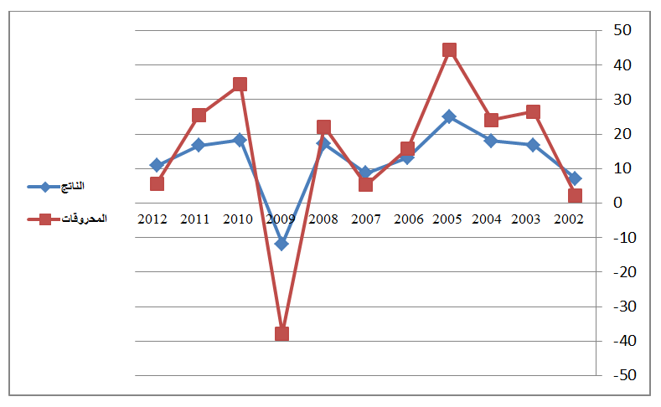 **Fig.1.** Figure title (this is an example of figure 1)

**Source:** *source source*

**3. EXPERIMENTAL**

This experimental section can be divided into subsections, the contents of which vary according to the subject matter of the article. It must contain all the information about the experimental procedure and materials used to carry out experiments.

**4. CONCLUSION**

The conclusion of a research paper needs to summarize the content and purpose of the article. The conclusion of a research paper needs to summarize the content and purpose of the article. The conclusion of a research paper needs to summarize the content and purpose of the article. The conclusion of a research paper needs to summarize the content and purpose of the article. The conclusion of a research paper needs to summarize the content and purpose of the article. The conclusion of a research paper needs to summarize the content and purpose of the article.

**5. Bibliography List :**

*the reference in the written in the following manner: (****Times New Roman12 interligne simple)***

1. ***Books :*** *author’s name (year), full title, publishing, country;*
2. ***Journal article :*** *author’s name (year), full title of the article, review name, place, volume and number ;*
3. ***Seminar article:*** *author’s name (year), full title of the paper, title of seminar, place and date, country ;*
4. ***Internet websites:*** *author’s name (year), full title of the file, detailed website :* [*http://fulladdress*](http://fulladdress) *(consulted on day/moonth/year).*

**6. Appendices**

**7. Citations[2]:**

1. *- Corresponding author: Full name, e-mail:* [*authorC@mail.com*](mailto:authorC@mail.com)*.*
2. - *Should be at the end of the document (Endnotes)*

   *(****Times New Roman 11, interligne simple)***