**Title ((Bodoni Bk BT; size -14 bold)**

**Author’s full name[1] (Bodoni Bk BT 12)**

**Institutional Affiliation – Country (Bodoni Bk BT12)**

**Electronic address(Bodoni Bk BT12)**

**ORCID ID :**

|  |  |  |
| --- | --- | --- |
| *Accepted 00/00/0000 Published 00/00/0000* |  | *Received 00/00/0000* |

**Abstract**

Two abstracts must be presented, one in English compulsory, and the second should be in the article language (Arabic, French or Spanish). Each abstract should not be less than 200 words; Abstracts in English should be written in Bodoni Bk BT; size 12, interline 1. A concise and structured abstract is required. The abstract should state briefly the purpose of the research, the methods, the principal results and major conclusions. Abstracts should be written in the third person “This article proposes . . . not the first person “I propose . . .”

**Keywords;** up to five keywords listed in an alphabetical order ( **a- b- c- d- e)**

**الملخص**

لا يقل محتوى الملخص عن 200 كلمة تكتب بخط **Sakkal Majalla** مقاس12**،**  تتضمن العناصر التالية:

* الهدف العام من الدراسة وإشكالية البحث التي تمت دراستها.
* التصميم الأساسي للدراسة متمثلا في منهج وأدوات الدراسة.
* النتائج التي تم الوصول إليها نتيجة تحليل البيانات.
* عرض موجز للاستنتاجات والتوصيات.

**الكلمات االدالة**: أ- ب- ج- د- ه

**Introduction**

The introduction should not be numbered. It should be presented in one block paragraph. The purpose of the introduction should be to supply sufficient background information to allow the reader to understand and evaluate the results of the present study without needing to refer to previous publication on the topic. The introduction should also provide the rationale for the present study. Above all, you should state briefly and clearly your purpose in writing the paper including a clear review of the pertinent literature and the method of investigation **(**12 point font (Bodoni Bk BT) 1 line spacing.

**Body of the text (**12 point font (Bodoni Bk BT) 1 line spacing.

Articles should be structured into sections, each with its own heading.

The titles of the article must be numbered.

No underlining for titles and subtitles.

No punctuation after titles: no double period at the end of a title (or at the end of a subtitle).

There may be three levels for headings (primary, secondary, tertiary in bold)

1. **The Primary Heading**

Content of the first title, content of the first title, content of the first title.

***1.1. The first secondary heading* (**12 point font (Bodoni Bk BT) 1 line spacing.

***1.2 The second secondary heading (***12 point font (Bodoni Bk BT) 1 line spacing.

***1.3 The third secondary sub-heading (***12 point font (Bodoni Bk BT) 1 line spacing.

***1.3.1 First tertiary heading (***12 point font (Bodoni Bk BT) 1 line spacing.

***1.3.2 Second tertiary heading (***12 point font (Bodoni Bk BT) 1 line spacing.

No space before the period, never a space before the comma.

Use the automatic page numbering function to number the pages.

Use tab stops or other commands for indents, not the space bar.

Tables and Figures

Please keep the title and captions brief while placing the titles above tables

Tables & figures must be followed by references.

Table model (if it exists): (included in the article)

**Table 1: Table title:** ………………………………..

|  |  |  |  |  |
| --- | --- | --- | --- | --- |
|  |  |  |  |  |
|  |  |  |  |  |
|  |  |  |  |  |

**Source:** ………………………………..

- Figure model (if it exists): (included in the article in image form, dressing in front of the text, regrouping the composite schemas).

**Figure 1: Figure title (**12 point font (Bodoni Bk BT) 1 line spacing.

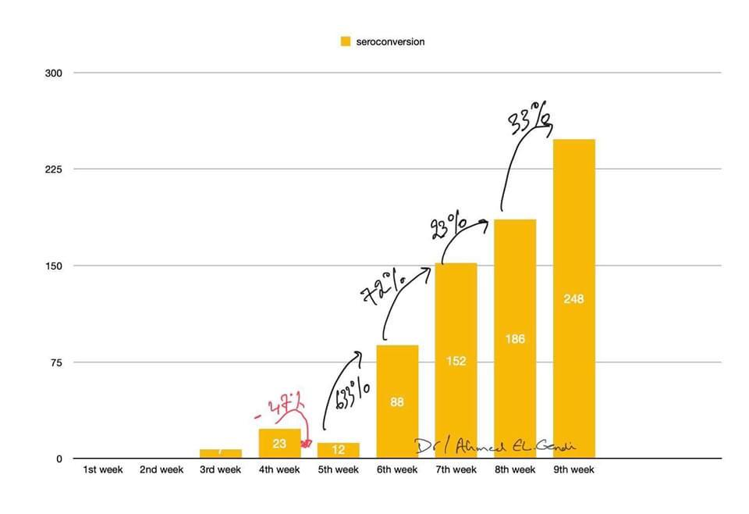

**Source:** …………………………….

**Citations**

Citations of other works should be limited to those which are strictly necessary. Short quotations should be included in the text within inverted commas (“ ”) while quotations of more than 30 words should be placed in a separate paragraph indented from the main body of the text. However, all quotations should be accompanied by precise references.

An [APA in-text citation](https://www.scribbr.com/?p=5892) ((also known as the author-date system). consists of the author’s last name and the year of publication. If you are citing a specific part of a source, you should also include a locator such as a page number or timestamp. For example: (Smith, 2020, p. 170).

No spaces after the opening quotation marks, nor before the closing quotation marks

**Parenthetical citation:** According to new research … (Smith, 2020).

**Narrative citation:** Smith (2020) notes that …

| **Author type** | **Parenthetical citation** | **Narrative citation** |
| --- | --- | --- |
| **One author** | (Smith, 2020) | Smith (2020) |
| **Two authors** | (Smith & Jones, 2020) | Smith and Jones (2020) |
| **Three or more authors** | (Smith et al., 2020) | Smith et al. (2020) |
| **Organization** | (Scribbr, 2020) | Scribbr (2020) |

**Conclusion**

The **Conclusion** should not be numbered.

A conclusion is an important part of the paper. It is usually one paragraph that simply and succinctly restates the main ideas and arguments, pulling everything together to help clarify the thesis of the paper. A conclusion does not introduce new ideas; instead, it should clarify the intent and importance of the paper.

**References)** size 12)References should be written in APA format

* Place the page right after the main body and before any appendices.
* On the [reference page](https://www.scribbr.com/?p=5761), you list all the sources that you’ve cited throughout your paper.
* On the first line of the page, write the section label “References” (in bold and centered). On the second line, start [listing your references in alphabetical order](https://www.scribbr.com/?p=5975)

**Printed Book (one author)**

Exp:

Williams, S. (2019). English Grammar: 100 Tragically Common Mistakes and How to Correct

Them. Emeryville, Clifornia: Zephyros Press.

**Printed Book (two or three authors)**

Exp:

Zinato, S., & Pes, A. (2013). Ex-Centric Writing: Essays on Madness in Postcolonial Fiction. New Castle: Cambridge Scholars Publishing

**Printed Book (more than three authors)**

Exp:

Dym, C.L., Little, P., Orwin, E.J., & Spjut, R.E. (2009). Engineering design: a project-

based introduction (3rd ed). Hoboken, NJ: Wiley.

**Journal articles**

Exp:

Yildiz, H. (2018) Freedom in Confinement: Women’s Prison Narratives and the

Politics of Possibility, Studies in Contemporary Fiction, 60(2): 143-156

**E-Book**

Exp:

Wear, A. (2000). Knowledge and practice in English medicine. Cambridge: Cambridge

University Press. Retrieved from <http://site.ebrary.com/lib/bham/detail.action?docID=5004608>

**Appendices**

List of annexes (if it exists): keep the same format as the tables and figures above.

1. Corresponding author:

   *Journal of Languages & Translation* © 2024. Published by University of Chlef, Algeria.

   This is an open access article under the CC BY license <http://creativecommons.org/licenses/by/4.0/>