**Title in English (Times New Roman; size-14; Interline simple)**

**Full name of the first author[1]  Full name of the second author**

Full affiliation, Email address Full affiliation, Email address

Received: XX January 20XX Accepted: XX January 20XX

|  |
| --- |
| **Abstract: Max 150 words**  **Title in English**  The abstract includes the objectives of the article and its problematic, the contents of the article ,and the substantive results. The abstract includes the objectives of the article and its problematic, the contents of the article ,and the substantive results. The abstract includes the objectives of the article and its problematic, the contents of the article ,and the substantive results. The abstract includes the objectives of the article and its problematic, the contents of the article ,and the substantive results. The abstract includes the objectives of the article and its problematic, the contents of the article ,and the substantive results. The abstract includes the objectives of the article and its problematic, the contents of the article ,and the substantive results.  **Key words: word1, word2, word3; word4, word5** |

**1. INTRODUCTION**

**2. First Subtitle**

The first subtitle opens with an introduction that presents the specific problem under study and describes the research strategy. The first subtitle opens with an introduction that presents the specific problem under study and describes the research strategy. The first subtitle opens with an introduction that presents the specific problem under study and describes the research strategy.

**3. Second Subtitle**

Enter here the text of second subtitle, enter here the text of second subtitle, enter here the text of second subtitle, enter here the text of second subtitle, enter here the text of second subtitle, enter here the text of second subtitle, enter here the text of second subtitle, enter here the text of second subtitle, enter here the text of second subtitle, enter here the text of second subtitle, enter here the text of second subtitle, enter here the text of second subtitle, enter here the text of second subtitle.

**4. RESULTS AND DISCUSSION**

Enter your results in this section, summarize the collected data and the analysis performed on those data relevant to the discourse that is to follow. After presenting the results, you are in a position to evaluate and interpret their implications, especially with respect to your original hypotheses.

**Table 1.** Table title (this is an example of table 1)

|  |  |  |  |  |
| --- | --- | --- | --- | --- |
| **Test 1** | **Test 2** | **Results 1** | **Results 2** | **Total Results** |
| 15.21 | 15.21 | 15.21 | 15.21 | 15.21 |
| 18.58 | 18.58 | 18.58 | 18.58 | 18.58 |
| 11.14 | 11.14 | 11.14 | 11.14 | 11.14 |

**Source:**

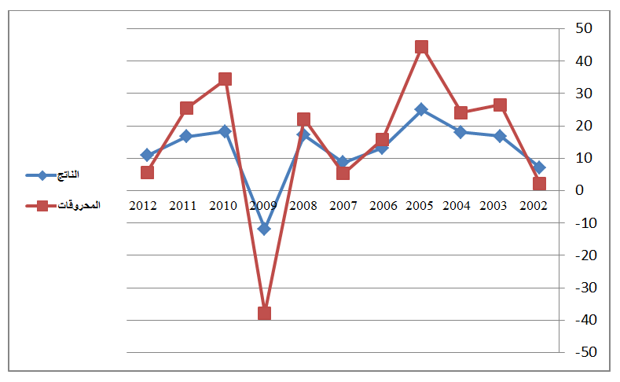 **Fig.1.** Figure title (this is an example of figure 1)

**Source:**

**3. EXPERIMENTAL**

This experimental section can be divided into subsections, the contents of which vary according to the subject matter of the article. It must contain all the information about the experimental procedure and materials used to carry out experiments.

**4. CONCLUSION**

The conclusion of a research paper needs to summarize the content and purpose of the article. The conclusion of a research paper needs to summarize the content and purpose of the article. The conclusion of a research paper needs to summarize the content and purpose of the article. The conclusion of a research paper needs to summarize the content and purpose of the article. The conclusion of a research paper needs to summarize the content and purpose of the article. The conclusion of a research paper needs to summarize the content and purpose of the article.

**5. Bibliography List :**

the reference in the written in the following manner: (**Times New Roman12 interligne simple)**

1. **Books :** author’s name (year), full title, publishing, country;
2. **Journal article :** author’s name (year), full title of the article, review name, place, volume and number ;
3. **Seminar article:** author’s name (year), full title of the paper, title of seminar, place and date, country ;
4. **Internet websites:** author’s name (year), full title of the file, detailed website : <http://fulladdress> (consulted on day/moonth/year).

**6. Appendices**

**7. Citations[2]:**

1. *- Corresponding author: Full name, e-mail:* [*authorC@mail.com*](mailto:authorC@mail.com)*.*
2. - Should be at the end of the document (Endnotes)

   (**Times New Roman 11, interligne simple)**